**Goal**

This exercise provides a practical example of how to use Azure Analytics to filter and analyze the data, creating the business report. During this exercise, the students will learn Azure IoT Analytics.

This tutorial is based on Veneri, Giacomo, and Antonio Capasso. **Hands-on industrial Internet of Things: create a robust industrial IoT infrastructure using industry 4.0.** Packt Publishing Ltd, 2018.

**Azure Analysis Services**

Azure Analysis Services is a fully managed platform as a service (PaaS) that provides enterprise-grade data models in the cloud. Use advanced mashup and modeling features to combine data from multiple data sources, define metrics, and secure your data in a single, trusted tabular semantic data model.

To use this capability, it is required to store the collected information in a highly scalable repository with which to store data for later analysis or visualization. One of the repositories supported by Azure is **Data Lake Storage**. We will use **Data Lake Storage Gen1** to store the results of our stream analytics, which we will look at in more detail in the Stream Analytics section.

Azure Data Lake Storage Gen1 is an enterprise-wide hyper-scale repository for big data analytics workloads. Azure Data Lake lets you capture data of any size, type, and ingest speed in one place for operational and exploratory analysis.

Data Lake Storage Gen1 can be accessed from Hadoop (available with the HDInsight cluster) using WebHDFS-compatible REST APIs. It was developed to allow an analysis of stored data and is tuned to work in data analysis scenarios. Data Lake Storage Gen1 includes all enterprise-class functionality: security, manageability, scalability, reliability, and availability.

**Task 1: Setting up Data Lake Storage**

To prepare our data lake repository, open the main Dashboard and create a new resource. Look for **Data Lake Storage Gen1** and click on **Create** button.

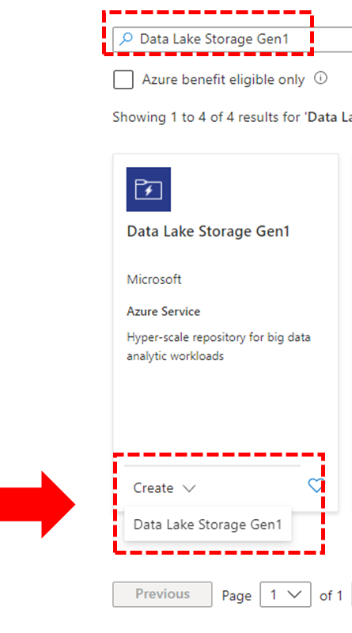

Next, you need to set the resource group (**iot_6_2_4**) and the service name (**datalake624**). The other information uses the default parameters. Click on the **Pricing** button.

In the Pricing panel, select Pay-as-You-Go and click on the **Review + Create** button. Azure will check if the configuration is ok, if it is ok a new button Create is shown. Click on it.

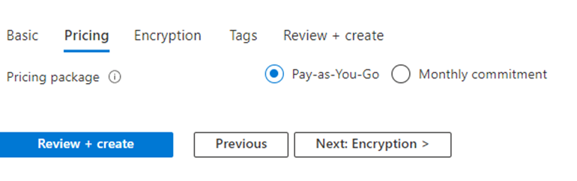

**Stream Analytics**

Azure provides three different frameworks that can be used to work with data: Stream Analytics, Data Lake Analytics, and ML Analytics.

Microsoft Azure Stream Analytics is a serverless scalable complex event processing engine by Microsoft that enables users to develop and run real-time analytics on multiple streams of data from sources such as devices, sensors, websites, social media, and other applications. Users can set up alerts to detect anomalies, predict trends, trigger necessary workflows when certain conditions are observed, and make data available to other downstream applications and services for presentation, archiving, or further analysis.

It enables to build of streaming pipelines in minutes, running complex analytics with no need to learn new processing frameworks or provision virtual machines (VMs) or clusters. It uses familiar SQL language that is extensible with JavaScript and C# custom code for more advanced use cases. Easily enable scenarios like low-latency dashboarding, streaming ETL, and real-time alerting with one-click integration across sources and sinks.

**Task 2: Using Streaming Analytics**

To use this feature, open the main Dashboard and create a new resource. Look for **Streaming Analytics Job** and click on **Create** button. As in the previous task, we set some properties and keep the default values in another. The resource group is the same (**iot_6_2_4**) and the instance name you set is **stream_job_624**. Also, confirm that the hosting environment is on Cloud.

Click on the **Review + Create** button. Azure will check if the configuration is ok, if it is ok a new button Create is shown. Click on it.

Once this is done, we need to define an input. From the Stream Analytics page, click on our job, then click on **+Add stream input** from the Inputs tab to add our IoT Hub input.

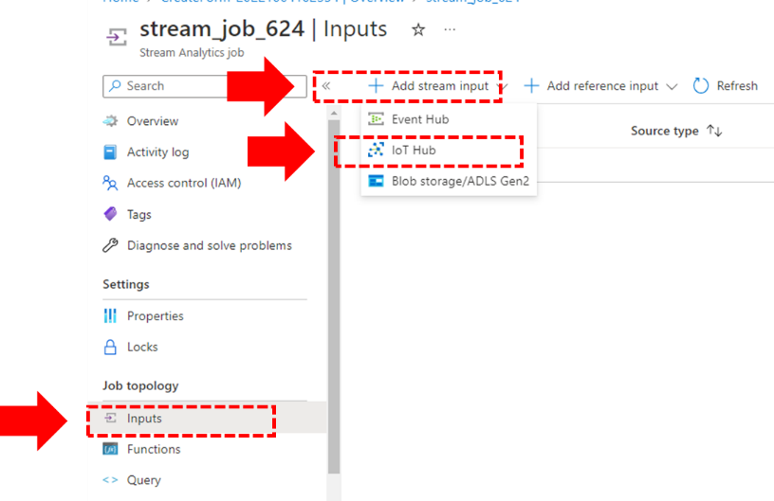

Define the name of the input alias to “**iothub**“ and assure that the IoT Hub name is correct. After it, click on the **Save** button.

The next step is the creation of a simple **user-defined function (UDF)** to calculate the efficiency, we can click on the Functions tab in the menu on the left, and create a JavaScript function, called efficiency.

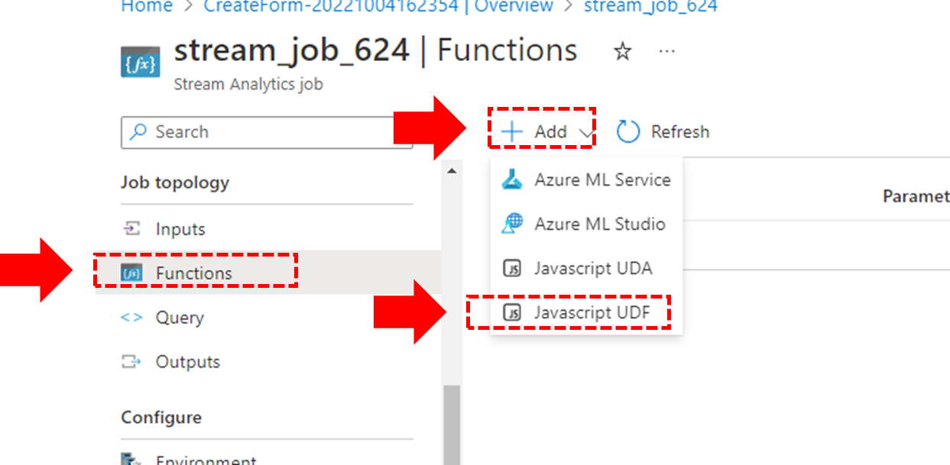

The next step is the definition of the JavaScript code and sets that the output is float.

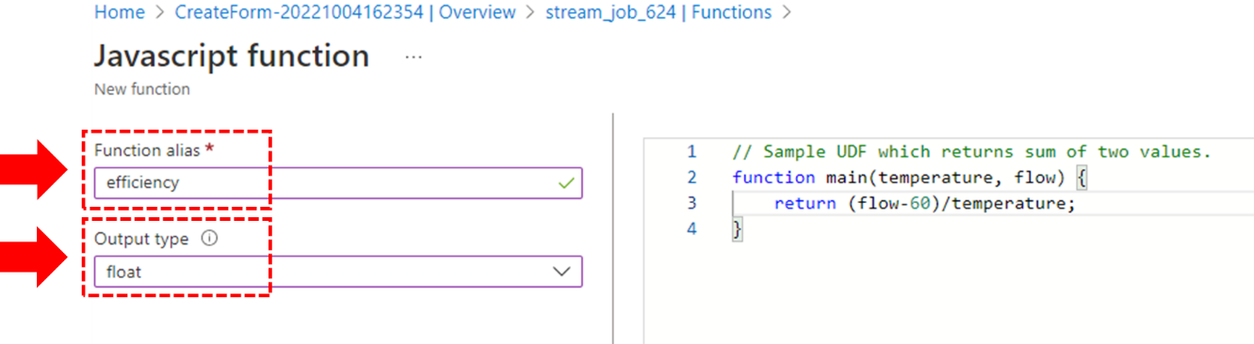

Following, we connect our output. From the Outputs tab, click on **+Add** and then **Data Lake Store**.

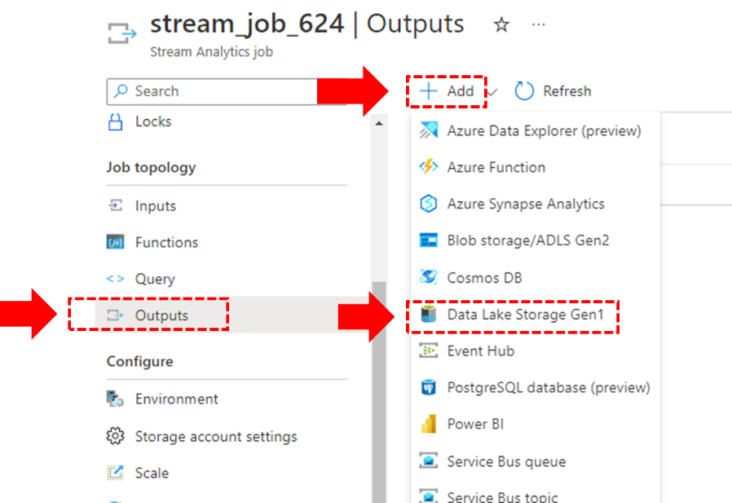

We must provide a name (**efficiencyoutput**), and a path prefix of **out/logs/{date}/{time}**. We need to change the Event serialization format option to CSV and the Delimiter option to tab. After that, click on **Save**.

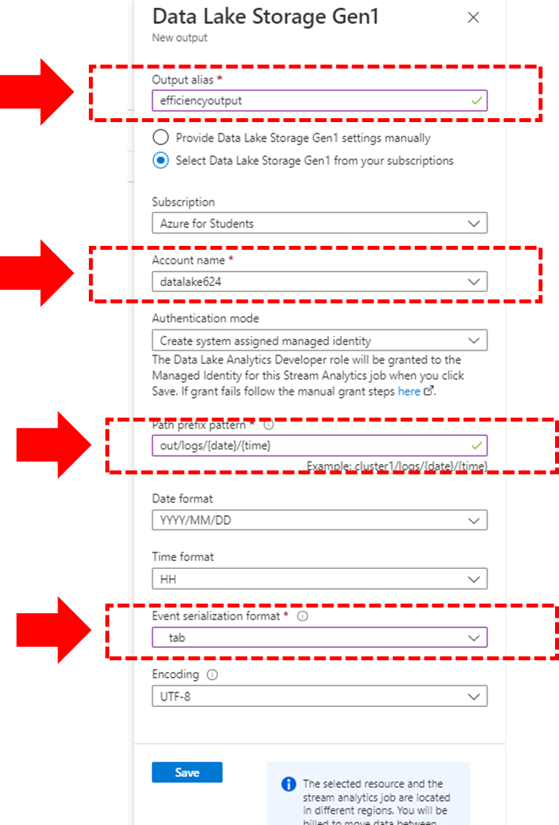

We are now ready to connect our input with our UDF and our output. From the Query tab, we can define this as follows. Remember to save the query.

SELECT

    deviceId AS device,

    ts,

    temperature,

    flow,

    udf.efficiency(temperature,flow)

INTO

    efficiencyoutput

FROM

    iothub

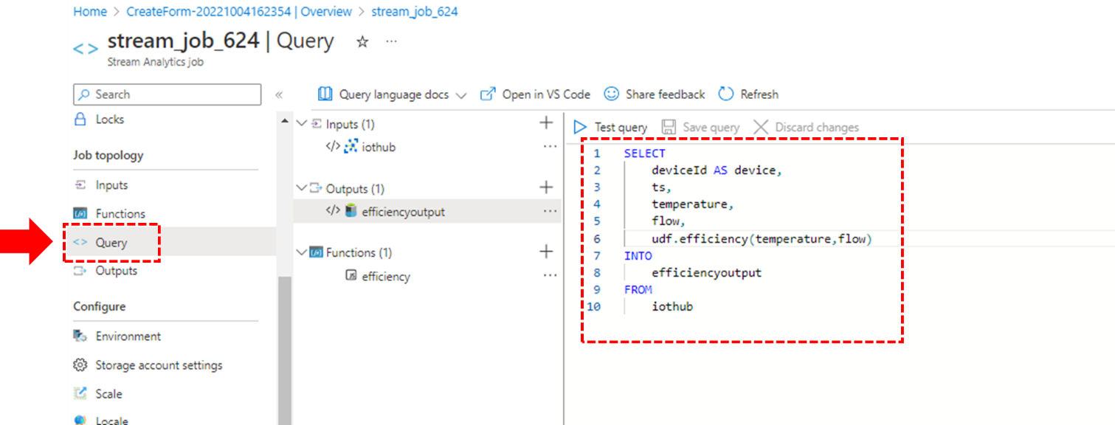

Return to the Dashboard of the Streaming Job, click on the **Property** panel, and check if the Input, Output, or Function appears. If they are not shown, click on **Refresh**. When the configuration is OK, click on the **Start** button to initiate the job.

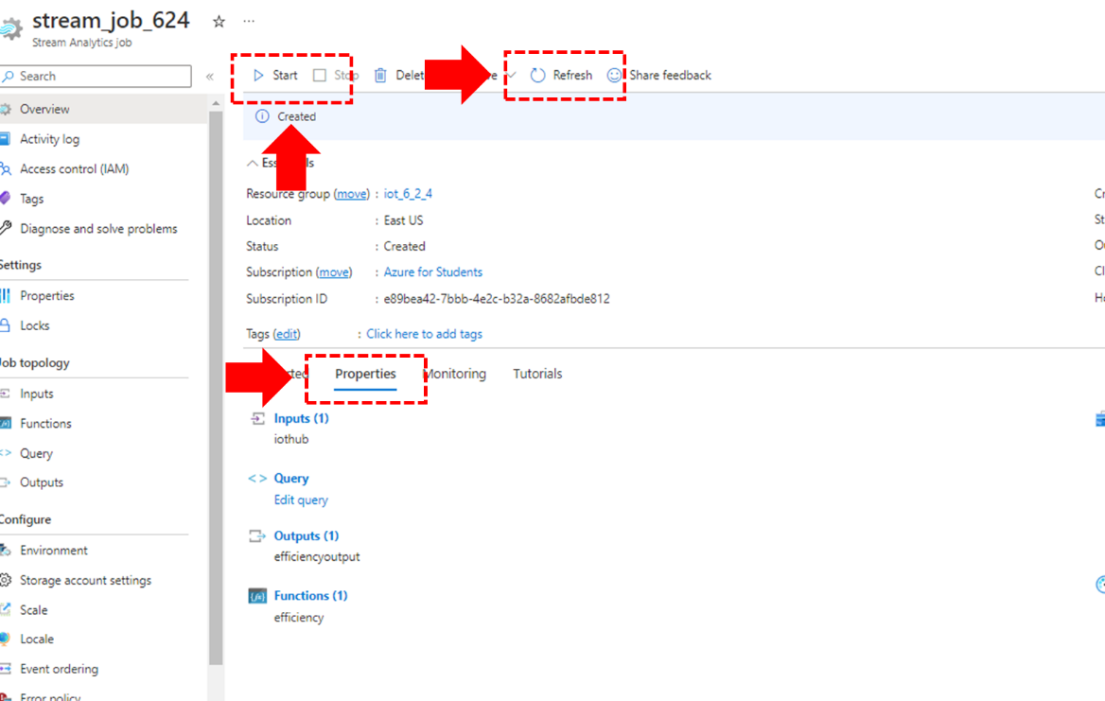

After you click on the **Start** button the job will be prepared. You need to confirm and click on the new **Start** button that appears on the right side of the Dashboard. After you click the button, the Dashboard is changed. If you stop the JavaScript app that you created in the last exercise, re-run and analyze the Dashboard information. If the information does not change, click again on the **Refresh** button.

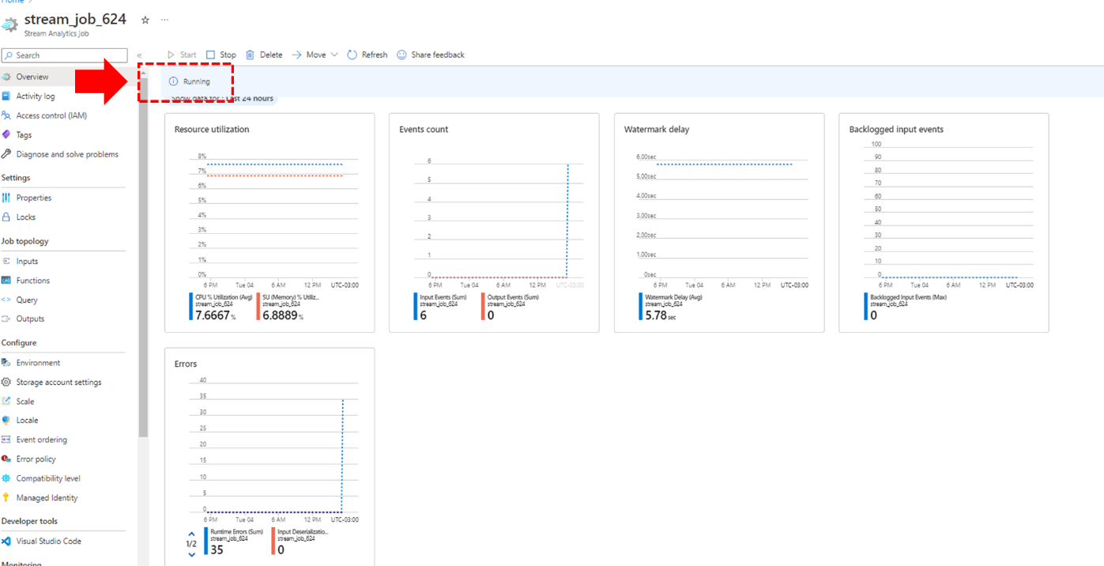

**After you test the functionality, remember to click on the Stop button, to stop the analytics from running to avoid unwanted billing, as in the JavaScript app.**